I have always wanted to know about vectors. So far, I only knew that in the computer world if I was dealing with a vector-based image then I could manipulate he size if that image without it becoming pixelated. There is a lot to learn in this area. My basic understanding is that in a simplest form a vector-based line is different from an image of a line. An image of a line is hard coded information about a selection of pixels that form that line. However, a vector-based line is information about the direction and the length of that line. This is the reason that they –vector-based graphics- are always clear and not pixelated. Once we know the direction and the length of the line, we are free to draw it in way that suite our local environment. How this leads to functions, arrays, and what happens with shapes (collections of vectors) should be a fascinating study.

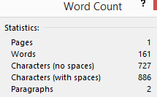

11/17/2013